Less is Moore: An Analysis and Redesign of Paint Sales

at a Small Neighborhood Paint Store

Susan Bryant, David Krum, Rahul Nair,

Susan Robinson, Kedar Shiroor, and Jesse Zolna

Engineering Psychology

Fall 2002

Less is More: An Analysis and Redesign of Paint Sales

at a Small Neighborhood Paint Store

Introduction
In recent years, the home improvement industry has experienced the emergence of large warehouse stores such as Home Depot and Lowe’s. While these stores have increased interest in home improvement, some have criticized them for taking business away from locally owned, neighborhood stores. Such stores include general neighborhood hardware stores and specialized stores that focus on such items as carpeting, wall coverings, appliances, and paint.
This paper details an analysis of the environment, equipment, and practices of a locally owned paint store. Some of the differences between this type of store and a warehouse store are noted. From this analysis, potential points of improvement are identified. Three alternatives for redesign are suggested: a fully automated version, a hybrid version, and a workspace revamp. The hybrid version is advanced as the best alternative and the impact on the store system is discussed. This paper is followed by an appendix containing raw observations, interview materials, and a copy of the group presentation.

Mission Statements
The mission of the small paint store is to sell paint to contractors and homeowners. It is in the interest of the store to differentiate itself from warehouse stores by ensuring that it provides higher quality paint and better customer service. The customer service consists of speed, attention, education, and carefully matching the product to the customer’s needs.

Mission Scenario 1: Expert user
Patrick the contractor needs paint for a job he’s doing. He goes to the paint store, walks to the counter, and places his order (specifying quantity, color, and base). He waits for the paint to be mixed, then he receives the can of paint, confirms that the color is correct, and accepts the paint.

Mission Scenario 2: Novice user
Paula wants to paint her living room a color she saw in a picture in a magazine. She takes the magazine to the paint store and indicates that she would like to match that color. She then asks what type of paint and how much paint would best fit her needs. She does not know how much paint she needs, but she knows the approximate size of the room and her ceiling height. She places her order, then she waits for the paint, confirms that the color is correct, and accepts the paint.

Mission Scenario 3: Employee/machine working with expert user
Employee/machine receives the order from the customer, specifying color, base, and quantity. Employee/machine gets a can of base paint (proper brand, size, type). Employee/machine looks up correct formula. Employee/machine opens can. Employee/machine adds correct pigmentation to the paint. Employee/machine closes paint can. Employee/machine shakes/spins can to mix pigment into paint. Employee/machine opens can, checks color, and puts some on the lid. Employee/machine alerts customer that paint is mixed. Employee/machine gets approval from customer (correct color, correct base). Employee/machine gives paint to customer.

Mission Scenario 4: Employee/machine working with novice user
Employee/machine receives incomplete order from customer. Employee/machine asks customer what color she wants. Customer indicates that she wants to match something. Employee/machine receives item displaying color to be matched then determines the correct color formula. Employee/machine asks customer what type of base she wants. If she does not know, employee/machine asks about the nature of the application – what type of surface is she painting (wall, trim, ceiling, wood, drywall, plaster, etc.), is it indoor or outdoor, [anything else?]. Based on customer’s answers, employee/machine determines the best base for that application. Employee/machine gets small amount of base paint, opens can and adds the color formula. Employee/machine then closes the can, shakes/spins the can to mix it, and opens the can. Employee/machine applies the paint to a surface similar to what the customer will be painting, dries the paint, then shows the paint to the customer and asks for her approval. If she approves the color, the employee/machine asks customer what quantity she would like. If she does not know, the employee/machine asks about the area she is going to paint. Based on the answer, the employee/machine determines the correct quantity. Employee/machine gets the correct type and size of base paint, opens can, adds the approved color formula, closes can, shakes/spins can, opens can, puts some paint on lid, closes can, Employee/machine shows paint to customer for her approval. After she approves it, employee/machine gives paint to customer.

Requirements
- Customer can place paint order in less than 2 minutes (after arriving at the paint counter).
- Speed: X gallons of paint mixed per hour (to meet demand)
- Errors: 0 machine errors, 3% errors (human side)
- One manhour per 10 customers per hour
- Scalable personnel in response to volume -- maintain ratio
- Color matching is accurate 97% of the time
- One person per color measuring/input
- Pays for itself in one year (through higher volume and less waste)
- Machine reads colors; no need to input numbers/brands
- Employee satisfaction and productivity – maintain current level of employee turnover
- Location: shouldn't take up any additional space, should be clearly visible to customers
- Shouldn't interfere with other tasks -- shopping, restocking, etc.
- Shouldn't be too loud
- Safety: no accidents (or number of accidents per manhour) for employees or customers
- Must be able to determine correct type of paint, color, and quantity based on information from the customer

Functional Flow and Decision Action Diagrams

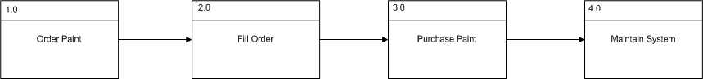

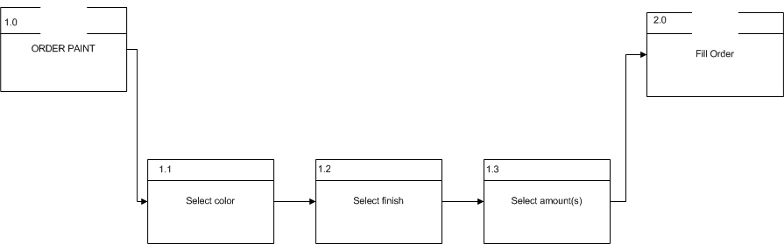

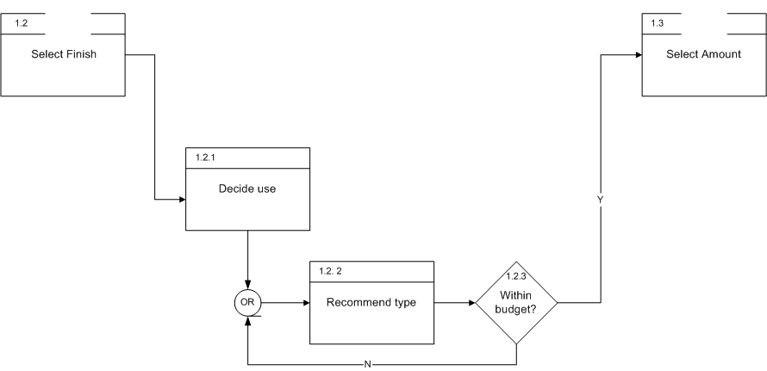

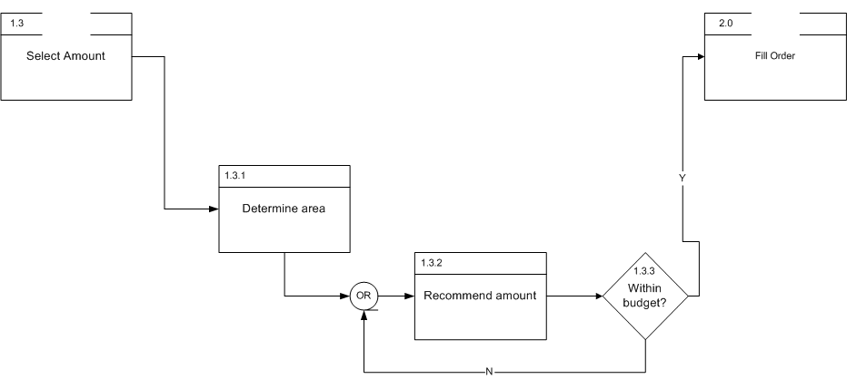

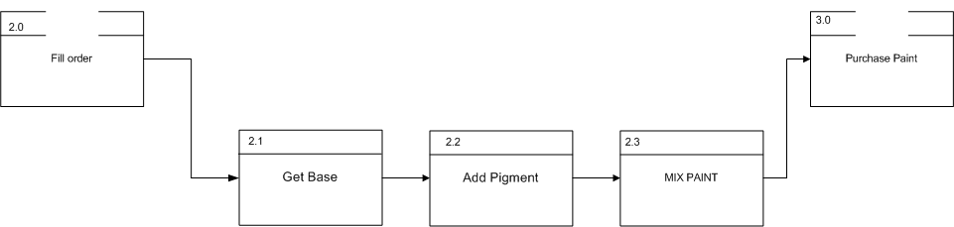

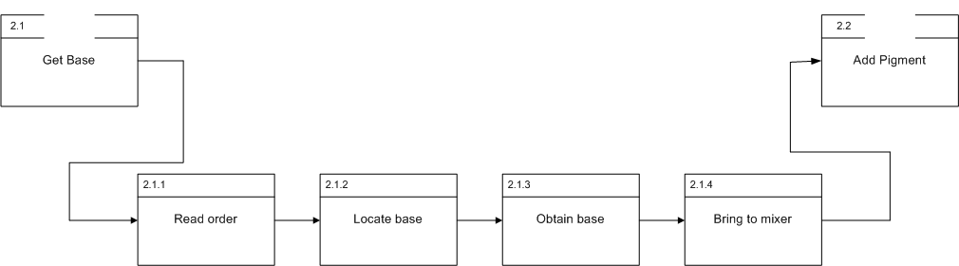

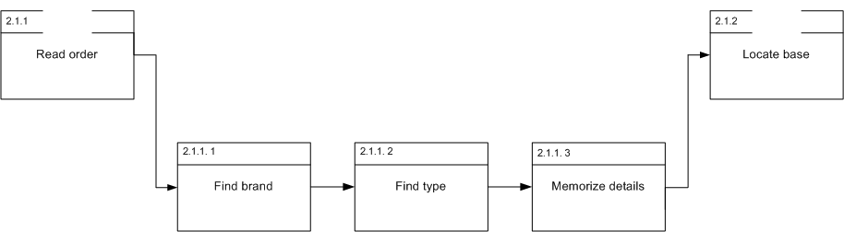

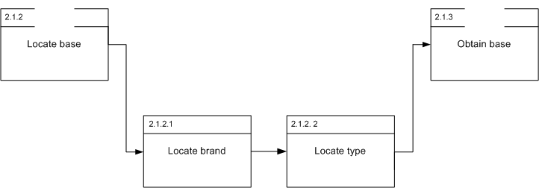

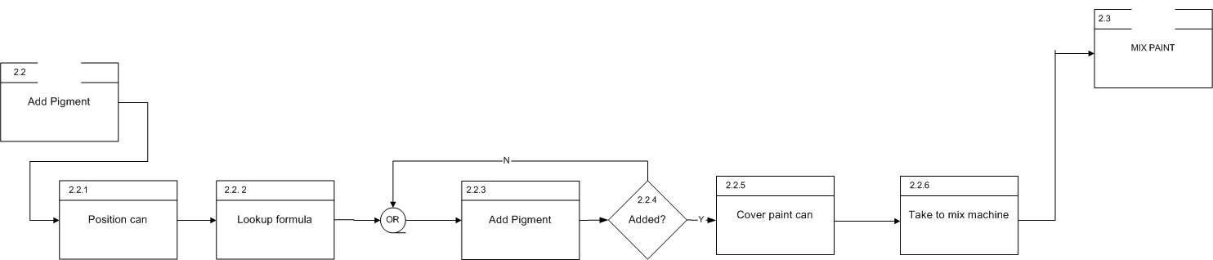

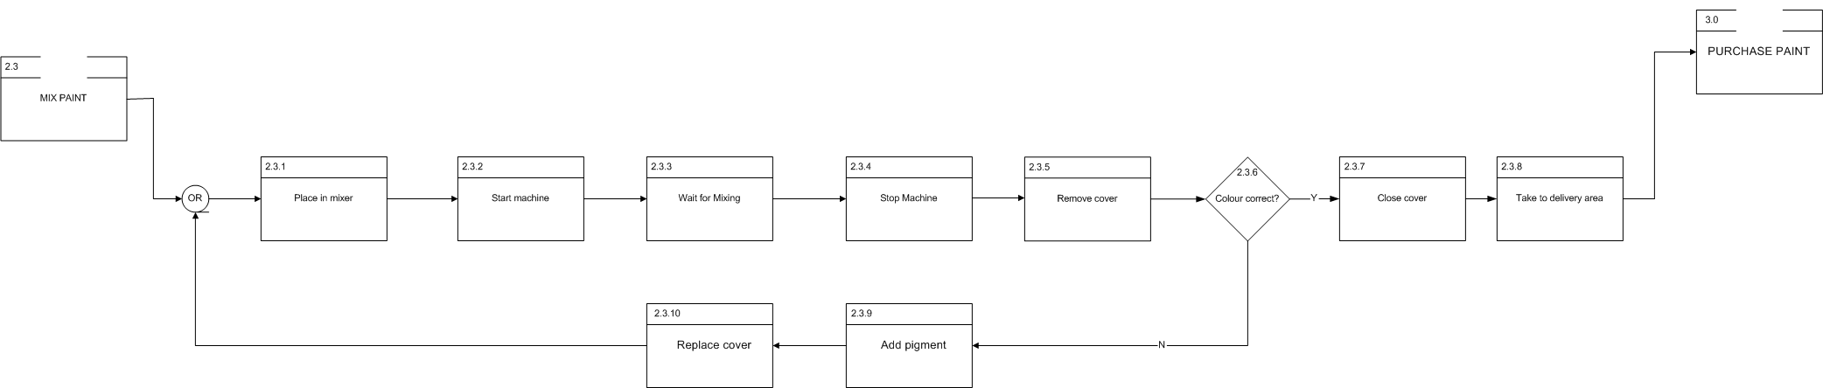

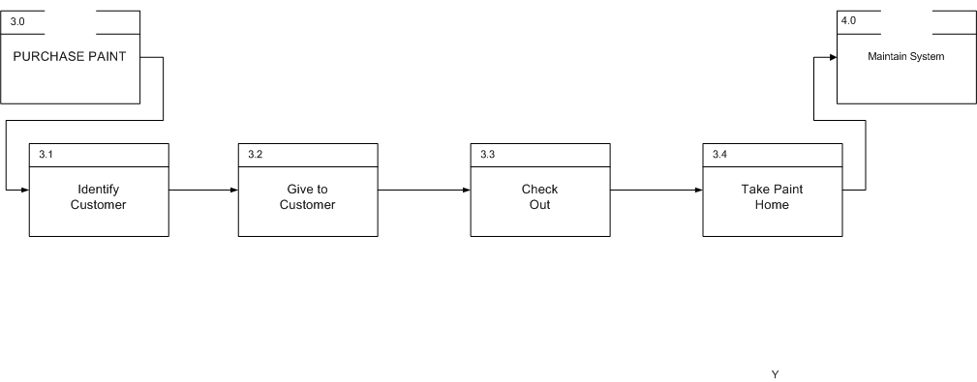

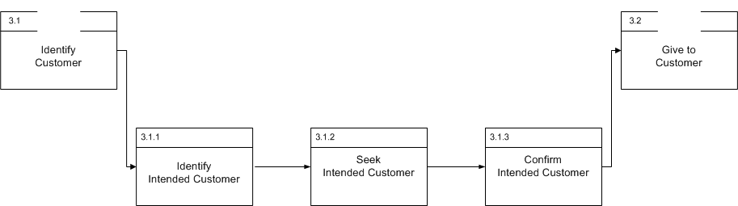

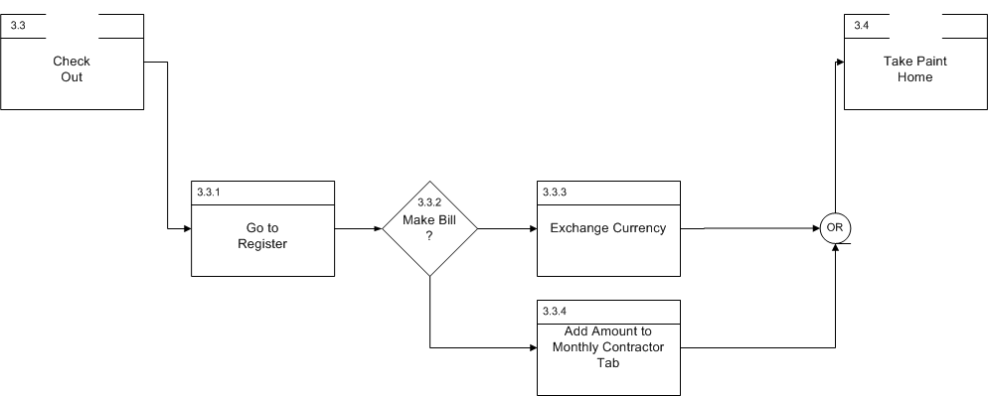

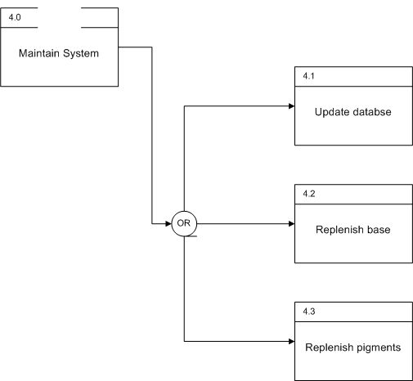

User Analysis
Interviews and observations at the paint store suggest that there are basically five types of individuals in the paint store system. There are three types of consumers: Novice Retail, Expert Retail, and Contractor. There are two types of employees: Novice and Expert.

Novice Retail Consumers
Novice retail consumers are buying paint for a home project. They typically buy smaller volumes of paint. They do not know much about paint bases, finishes, or colors. They typically need assistance in choosing colors and types of paint.

Expert Retail Consumers
Expert retail consumers are also buying small volumes of paint for a home project. They have typically bought paint before, but not necessarily from a specialized paint store, so they might be unfamiliar with the particular brand. They do know the general type and color of paint they require.

Contractor Consumers
The contractor consumer is an employee/owner of a business that uses paint. This may be a painting company or a more general contractor who does painting as part of other construction and remodeling.
- Buys large volumes of paint
- Billed at end of month
- Typically orders paint in advance by phone or in person
- Often picks up paint on Mondays
- Is knowledgeable about paint and knows what is required

Novice Employees
All employees hired by the paint store are required to have some prior knowledge of paint. However, they need to gain knowledge about the products carried by the store. Novice employees are typically closely watched and trained before they can mix paint by themselves. They most likely perform duties that require less expertise, such as inventory and clean up.

Expert Employees
Expert employees have several years experience working in a paint store. The three employees who were interviewed had been working in paint for three, ten, and fifteen years. Such employees are knowledgeable about the products in the store and which are appropriate for a given customer. They may be able to match paint colors by eye.

Environmental Analysis
The store is located in a suburban strip mall next to a grocery store. The store is narrow and deep, with glass windows and doors at the front of the store. The store counter and paint mixing stations are located at the rear of the store.
Paint mixers are the noisiest of the equipment currently in the store, but they cause intermittent noise. Since conversation between employees and customers is important, minimal noise is needed. A standard indoor climate is maintained. However, due to the amount of inventory and the shape of the store, space is limited.
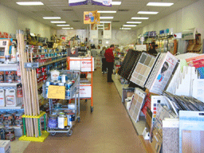
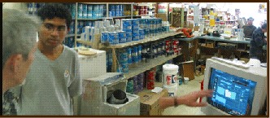
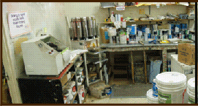
Figure 1: Photos of Store Interior

Diagram of Store
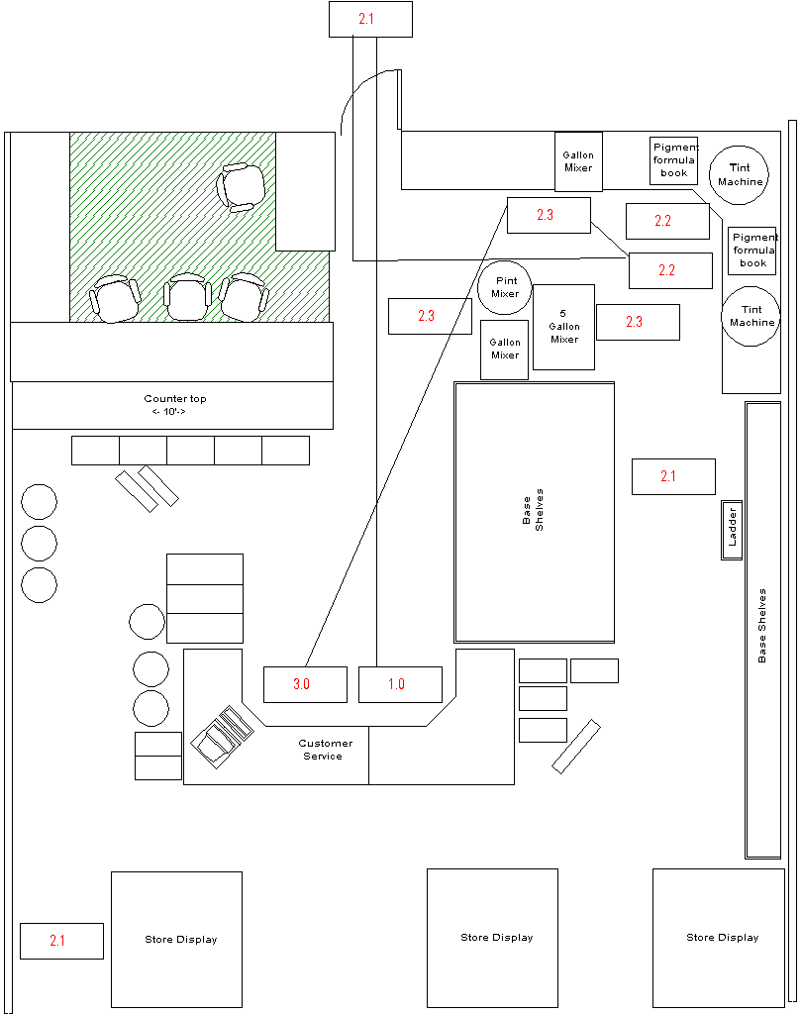
Figure 2: Current Workspace Layout

Function Allocation
Most functions are currently allocated to humans. Exceptions include paint matching by spectrograph (although humans usually tweak the formula manually) and paint shaking.
Number | Name of Function | Customer | Contractor | Employee | Machine
1.0 | Order Paint
1.1 | Select color | x | x | x | x
1.1.1 | From sample (match)
1.1.2 | From standard chips
1.1.3 | From reference color
1.2 | Select finish: matte, semi-gloss, gloss
1.3 | Select desired amounts (gallons, quarts)
2.0 | Fill Order
2.1 | Determine base and tints
2.1.1 | Match chip? |  |  |  | x
2.1.1.1 | Scan chip |  |  |  | x
2.1.1.2 | Receive tint, base values |  |  | x
2.1.1.3 | Take tint, base values to mixing station |  |  | x
2.1.2 | Standard Chip?
2.1.2.1 | Look up chip color values |  |  | x | x
2.1.2.2 | Receive tint, base values |  |  | x
2.1.2.3 | Take tint, base values to mixing station |  |  | x
2.1.3 | Reference Color (other vendor)?
2.1.3.1 | Look up chip color values |  |  | x | x
2.1.3.2 | Receive tint, base values |  |  | x
2.1.3.3 | Take tint, base values to mixing station |  |  | x
2.2 | Mix paint
2.2.1 | Retrieve base |  |  | x
2.2.1.1 | Retrieve proper base |  |  | x
2.2.1.2 | Retrieve proper base amount |  |  | x
2.2.2 | Take base to tinting station |  |  | x
2.2.3 | Add tints (indicated in formula) |  |  | x
2.2.4 | Add opt. components: fungicides, etc. |  |  | x
2.2.5 | Blend base and tints (shake) |  |  |  | x
2.2.6 | Check/adjust color w/ addnt tint (if needed) |  |  | x
2.2.7 | Take mixed paint order to purchase area |  |  | x
3.0 | Purchase Paint
3.1 | Total Order | x | x | x
3.2 | Add Order to Monthly Contractor Tab | x | x | x
3.3 | Exchange currency for paint | x | x | x
4.0 | Maintain Paint Order System
4.1 | Update color matching database |  |  | x
4.2 | Replenish base paints |  |  | x
4.3 | Replenish colorants |  |  | x
4.4 | Clean Colorant Tops |  |  | x
4.5 | Clean Colorant Nozzles |  |  | x

Task Analysis
The task analysis that follows covers the paint tinting and mixing process. Observation data and interviews indicated that it was during these tasks that most errors occurred. “Find Correct Book” is a step where errors can be made by new employees. Paints of different base and gloss require different formula books. After locating the formula, the employee uses a placeholder to mark the formula. Then, working from memory of the correct formula, the employee adds each component pigment to the base paint, working through each color of the formula. This can be very error prone, especially because several portions of a single pigment may be added. Also, because an employee must remember each formula component and count portions, distractions easily cause errors.
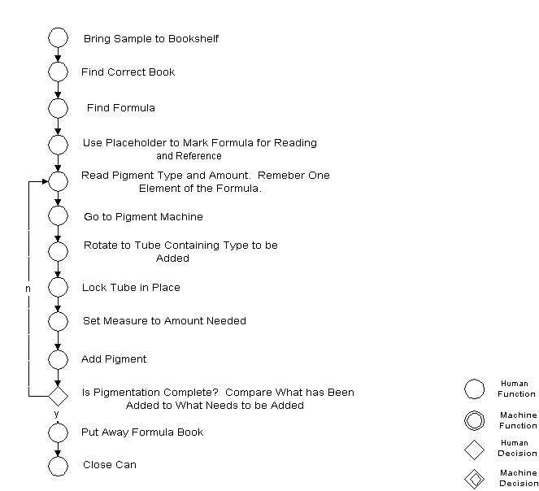
Figure 3: Current Task Analysis

Workload Analysis
Several things should be noticed in the workload. While there are no parallel tasks, a number of small quick steps must be performed a certain number of times. Because the tinting machine can only measure 2 oz. portions at a time and some shades of paint may require up to 25 oz. of pigment, employees need to measure out multiple portions. It is easy to over or under tint due to repetition. It also takes a lot of time to find the correct formula book (and perhaps double check that it is the correct book) and find (and double check) the formula.
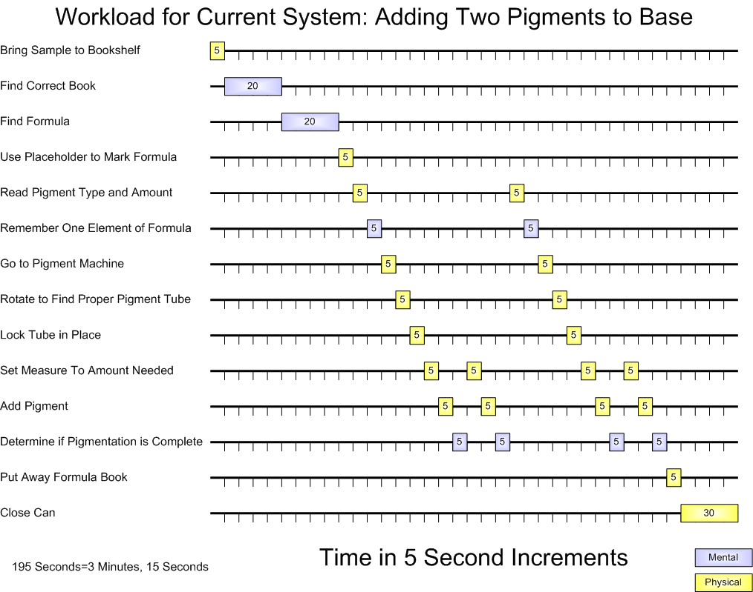
Figure 4: Current Workload

Evaluation and Recommendations for Improvements

Displays
Employees, particularly new employees, often make paint formula mistakes because they look up formulas in the wrong formula book. There are five formula books with small type, and employees must decide which book is the appropriate one, find it, and then look up the formula. The two-letter pigment abbreviations also sometimes cause confusion, as “TG” pigment is sometimes mistaken for “OG” pigment. This confusion can cause employees to add the wrong color to a can of base. Also employees must read the type and amount of each pigment, remember it, and travel to the tinting machine to add pigment. The errors could be prevented by using a nearby display instead of reliance on memory. The same errors can occur with color matching. The color match formula is printed in small type by a dot matrix printer. Although the employee is able to carry the written formula to the tinting machine, it can be difficult to read. A clear, accessible display of the correct formula would help to reduce these kinds of errors. Another way of preventing errors would be to have an indicator to confirm whether the pigment selection is correct and when the pigment addition task is completed.
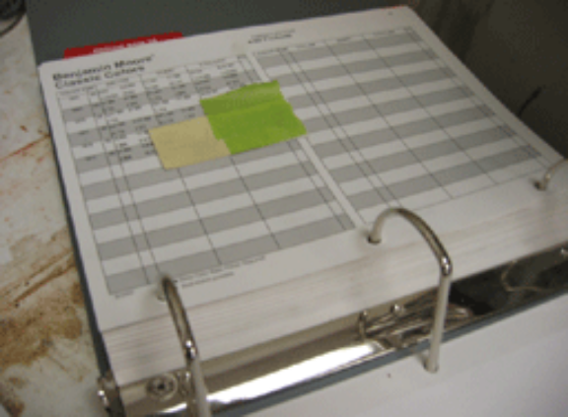  Figure 5: One of Five Formula Books | 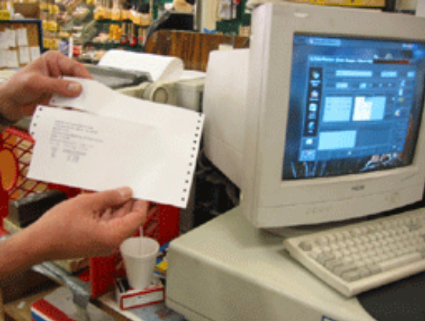  Figure 6: Formula Printed by Color Match Computer

Controls
The current tinting machine can measure out pigment in up to 2 oz. portions. Some colors formulas can require as much as 25 oz. of one color. This requires 13 applications of pigment with the current machine. A tinting machine that can measure 7 oz. portions is currently available, and in interviews employees suggested that a larger capacity tinting machine be used.
A computer is used to color match with a spectrometer and also look up paint formulas for other brands of paint in a database. There is a keyboard and a mouse that is often operated with the left hand due to a lack of space.
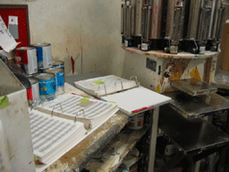  Figure 7: Current 2 oz. Tinting Machine | 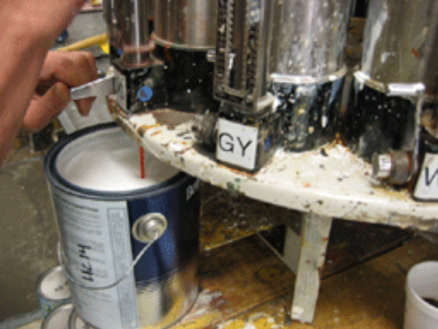  Figure 8: Manual Addition of Tint

Workspace Layout
The current layout of the store has a number of issues and could be improved. Base paint is located at various positions around the store. This can sometimes result in an employee carrying base paint the whole length of the store. These cans come in quart, gallon, and five gallon sizes. The sequence of operations required in mixing paint might cause two or more employees to cross paths, awkwardly step around each other, or even collide. Equipment and materials that are used in sequence are not located in adjacent positions. Lighting is not adequate where displays and text are read.
The following diagram of a proposed workspace rearrangement addresses many of the issues with the current layout. A rear loading set of shelves consolidates all the base paint in one location. The base paint relocation means that employees do not have to carry base paint as far, there are fewer opportunities for collisions of employees, and it can be easily restocked from the back storeroom. Also, employees can more easily find the correct base paint because it will all be in one place. Lighting around the tinting machines is improved, allowing employees to see better. Equipment and materials are laid out to enable a circular flow of sequential work to avoid collisions of employees and to shorten the time it takes to complete the process. The customer counter is doubled in size so more customers can be helped and to give them more space.
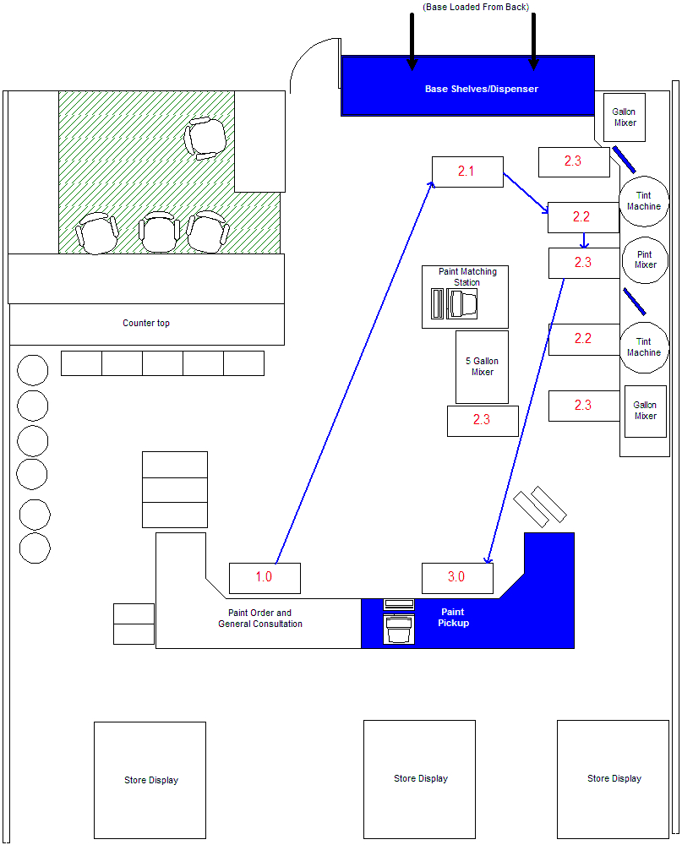
Figure 9: Redesigned Workspace Layout

Anthropometry
It is somewhat difficult to get to base paint located on high shelves in the front of the store. A set of paint cans on the floor are often used as step stools, obviously creating a potentially dangerous situation. This difficulty also applies to restocking base. Pigment canisters must be reloaded and occasionally cleaned. Because the tinting machine is located on a countertop and the canisters are tall, reloading and cleaning can require a ladder or step stool.

Redesign

Alternative 1: Workspace Revamp
The first alternative was a simple workspace revamp. This involves rearranging components of the store, without introducing new equipment. The base paint in the current system is located in several locations around the store. Since base paint is delivered to a back storeroom, a double sided shelf unit at the back of the store would consolidate the base in a single location. The shelf unit could be loaded with base paint from the back inside the store room and base paint could be retrieved from the front. Also, materials and machines that are used in sequence should be adjacent. This creates a circular workflow without areas of crossing traffic and potential collision. Furthermore additional lights over the tinting area make it easier to read formulas.

Alternative 2: Complete Automation
The second alternative involved complete automation of the tinting process. Each tinting machine is controlled by a computer which performs selection, measurement, and addition of pigments. Each tinting machine has a bar code reader which allows formulas to be automatically retrieved from paint chips. Each tinting machine also has a spectrometer which allows color formulas to be derived by color matching. Manual control is also possible to allow for small adjustments in color.
This design alternative also includes the same workspace rearrangement as in the workspace revamp redesign.

Alternative 3: Partial Automation
The final alternative is the partial automation of the tinting process. Each tinting machine has a bar code reader which allows formulas to be automatically retrieved from paint chips. There is a single spectrometer for paint matching. The resulting formula from the paint matching is printed as a bar code that can be read by the tinting machines. A large display allows specification of base and gloss, which may affect the formula. To maintain the special cachet that hand tinting offers, employees manually add tints. However, there are two important variations. The system monitors which pigments the employee adds and marks off each pigment on the formula display as it is added. A green or red light located on the tinting machine indicates whether the pigment is correct or incorrect. Furthermore, the new tinting machine is of higher capacity, 7 oz. or larger, allowing large amounts of pigment to be added in fewer steps. The following diagrams describe the displays for the redesigned paint tinting system.
This design alternative also includes the same workspace rearrangement as in the workspace revamp redesign.
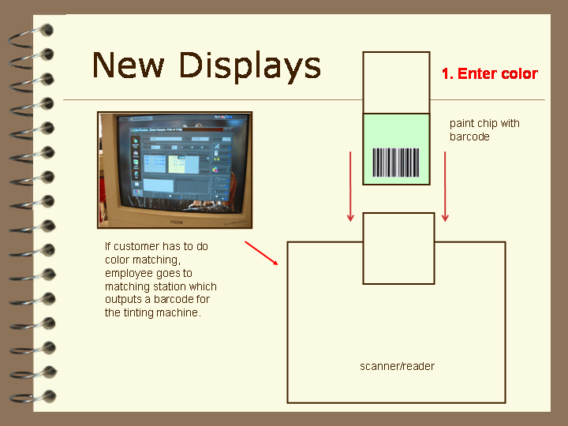

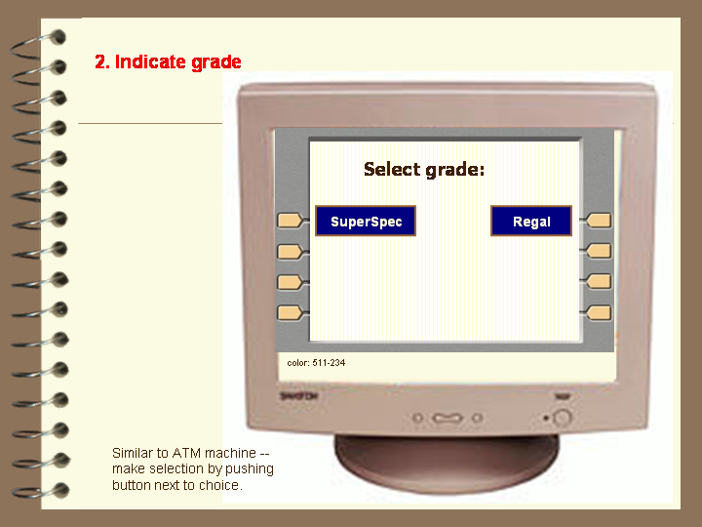

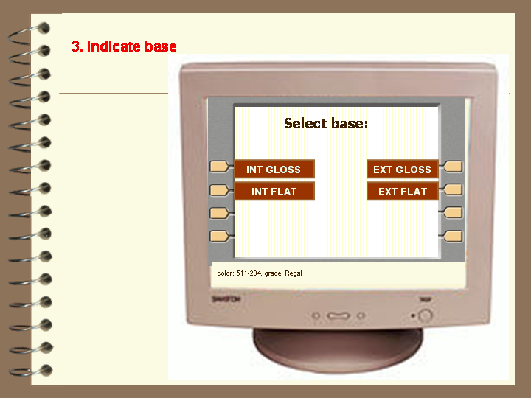

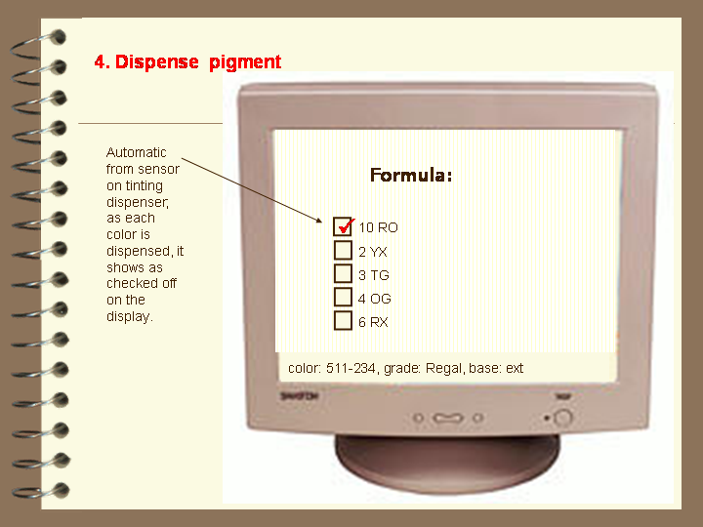

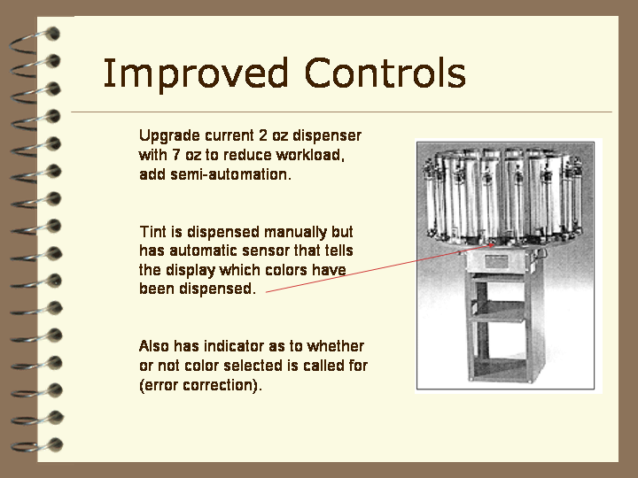

Alternative Design Analysis
The three alternative designs were considered with the following criteria in mind. These criteria were assigned relative weightings of importance after a process of binary comparison. Some of the important criteria were obvious and common: safety, speed, reducing errors, and cost. Cost was of great concern since much of the equipment in use at the store had not been replaced in years. Equipment is an investment for the store and good equipment could last for decades. The pigment adding machines are 15 years old. Some of the paint shakers may be even older.
Some of the important criteria were less obvious. The most important criteria were store image and customer relationship. These set the store apart from large warehouse stores. Customers must perceive that they are given special attention and given a carefully and thoughtfully handcrafted product. It is unknown whether this product is measurably or statistically purer or more consistent.
The final scores for each of the redesign alternatives are shown below.

Criteria
Criteria | Weighting
Safety | 7.69230769
Store image | 15.38462
Help customer relationship | 14.1025641
Shouldn't be too loud | 3.84615385
Not interfere with other business activity | 5.128205
Minimal space requirements | 7.692308
Employee satisfaction | 5.12820513
Cost | 8.97435897
Manpower/efficiency | 2.564103
Color matching accuracy | 11.53846
Scalable staffing (can be run by one or many operators) | 0
Minimize physical mixing/formula errors | 11.53846
Speed | 6.410256

Binary Comparison
 | Full Auto | Partial | Full Auto | Revamp | Hybrid | Revamp
Store image | 0 | 1 | 0 | 1 | 1 | 0
Safety | 1 | 0 | 1 | 0 | 1 | 0
customer relationship | 0 | 1 | 0 | 1 | 1 | 0
shouldn't be too loud | 0 | 1 | 1 | 0 | 1 | 0
not interfere | 1 | 0 | 1 | 0 | 1 | 0
Space | 1 | 0 | 1 | 0 | 1 | 0
employee satisfaction | 0 | 1 | 1 | 0 | 1 | 0
Cost | 0 | 1 | 0 | 1 | 0 | 1
manpower/efficiency | 1 | 0 | 1 | 0 | 1 | 0
color matching accuracy | 1 | 0 | 1 | 0 | 1 | 0
scalable staffing | 1 | 0 | 0 | 1 | 1 | 0
physical mixing/formula errors | 1 | 0 | 1 | 0 | 1 | 0
Speed | 1 | 0 | 1 | 0 | 1 | 0

Weightings
 | Full Auto | Hybrid | Full Auto | Revamp | Hybrid | Revamp
Store image | 0 | 7.69230769 | 0 | 7.692308 | 7.692308 | 0
Safety | 15.38462 | 0 | 15.38462 | 0 | 15.38462 | 0
customer relationship | 0 | 14.1025641 | 0 | 14.10256 | 14.10256 | 0
shouldn't be too loud | 0 | 3.84615385 | 3.846154 | 0 | 3.846154 | 0
not interfere | 5.128205 | 0 | 5.128205 | 0 | 5.128205 | 0
Space | 7.692308 | 0 | 7.692308 | 0 | 7.692308 | 0
employee satisfaction | 0 | 5.12820513 | 5.128205 | 0 | 5.128205 | 0
Cost | 0 | 8.97435897 | 0 | 8.974359 | 0 | 8.974359
manpower/efficiency | 2.564103 | 0 | 2.564103 | 0 | 2.564103 | 0
color matching accuracy | 11.53846 | 0 | 11.53846 | 0 | 11.53846 | 0
scalable staffing | 0 | 0 | 0 | 0 | 0 | 0
physical mixing/formula errors | 11.53846 | 0 | 11.53846 | 0 | 11.53846 | 0
Speed | 6.410256 | 0 | 6.410256 | 0 | 6.410256 | 0

Final Scores
Full Auto | Hybrid | Revamp
129.4872 | 130.769231 | 39.74358974

Redesigned Function Allocation
There were a few small changes to the function allocation in the redesign. Some functions that were previously only done by humans are now shared by both human and machine. Steps 2.1.1.2, 2.1.1.3, and 2.2.3 are still done by an employee but receive more machine assistance. Specifically, a barcode and barcode reader helps the employee to look up and transfer color formulas to the mixing station. A pigment checking system built into the tinting machine also helps the employee confirm that they are adding the proper pigments.
Number | Name of Function | Customer | Contractor | Employee | Machine
1.0 | Order Paint
1.1 | Select color | x | x | x | x
1.1.1 | From sample (match)
1.1.2 | From standard chips
1.1.3 | From reference color
1.2 | Select finish: matte, semi-gloss, gloss
1.3 | Select desired amounts (gallons, quarts)
2.0 | Fill Order
2.1 | Determine base and tints
2.1.1 | Match chip? |  |  |  | x
2.1.1.1 | Scan chip |  |  |  | x
2.1.1.2 | Receive tint, base values |  |  | x | x
2.1.1.3 | Take tint, base values to mixing station |  |  | x | x
2.1.2 | Standard Chip?
2.1.2.1 | Look up chip color values |  |  | x | x
2.1.2.2 | Receive tint, base values |  |  | x
2.1.2.3 | Take tint, base values to mixing station |  |  | x
2.1.3 | Reference Color (other vendor)?
2.1.3.1 | Look up chip color values |  |  | x | x
2.1.3.2 | Receive tint, base values |  |  | x
2.1.3.3 | Take tint, base values to mixing station |  |  | x
2.2 | Mix paint
2.2.1 | Retrieve base |  |  | x
2.2.1.1 | Retrieve proper base |  |  | x
2.2.1.2 | Retrieve proper base amount |  |  | x
2.2.2 | Take base to tinting station |  |  | x
2.2.3 | Add tints (indicated in formula) |  |  | x | x
2.2.4 | Add opt. components: fungicides, etc. |  |  | x
2.2.5 | Blend base and tints (shake) |  |  |  | x
2.2.6 | Check/adjust color w/ addnt tint (if needed) |  |  | x
2.2.7 | Take mixed paint order to purchase area |  |  | x
3.0 | Purchase Paint
3.1 | Total Order | x | x | x
3.2 | Add Order to Monthly Contractor Tab | x | x | x
3.3 | Exchange currency for paint | x | x | x
4.0 | Maintain Paint Order System
4.1 | Update color matching database |  |  | x
4.2 | Replenish base paints |  |  | x
4.3 | Replenish colorants |  |  | x
4.4 | Clean Colorant Tops |  |  | x
4.5 | Clean Colorant Nozzles |  |  | x

Redesigned Task Analysis
While there appear to be more steps in the redesigned task analysis, many of these steps are performed by the computer in parallel to double check and confirm the employee’s pigment selections. There also appear to be two decision steps creating two loops. Again, one of these decision steps and one of the loops are performed by the machine in parallel with the human’s actions.
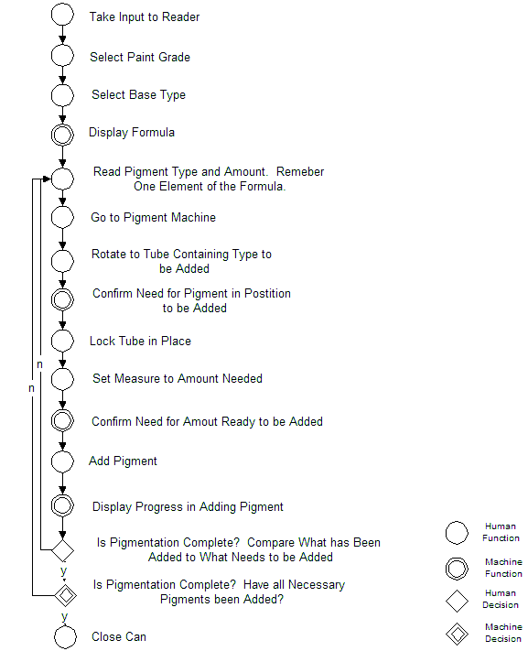

Redesigned Workload Analysis
The workload for the redesigned system shows a number of savings. The step to select the correct formula book is replaced by a step by step specification of paint grade and paint type. With a barcode lookup system and a large display near the tinting machine, the employee does not need to continually travel to a formula book and find and read a formula that is printed in small type. Also, the formula display is improved to be easier to read and with the added capability of tracking and displaying which pigments in the formula have been added. Furthermore, a larger capacity tinting machine means that employees do not need to continually add portion after portion of pigment. The workload analysis suggests that a 55 second savings might result with the redesign.
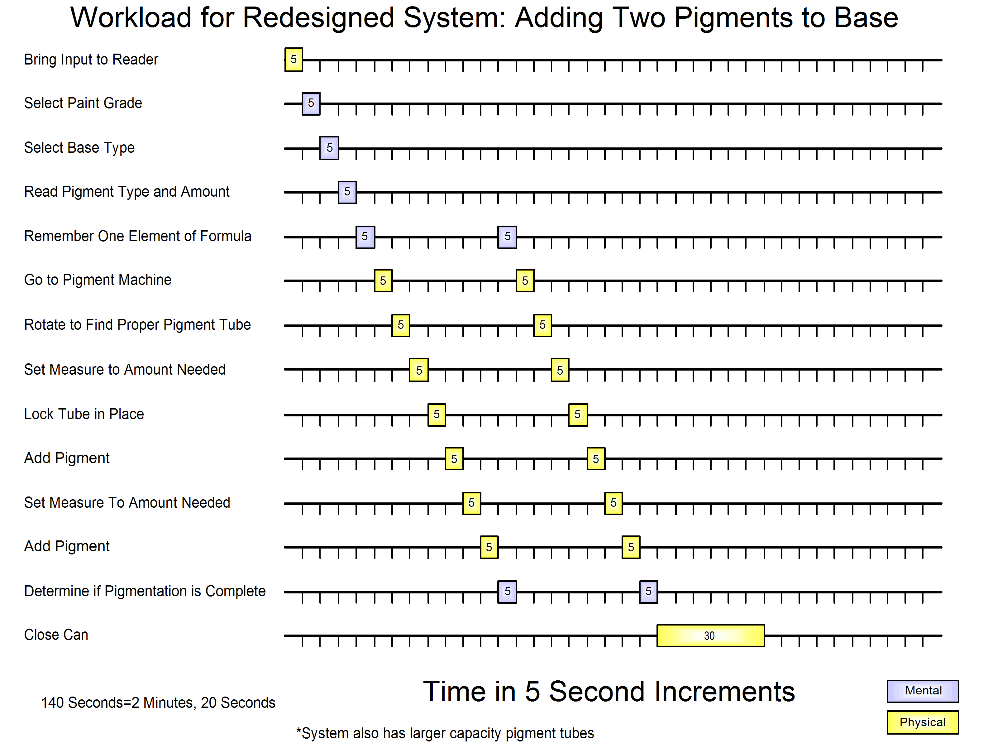
Figure 10: Redesigned Workload

Conclusion
This was a very interesting project since it immersed the group in many details of the paint business. We were exposed to a variety of techniques and skills involved in paint sales, paint selection, and paint matching. Since we began the project with observations at a paint counter in large warehouse stores, we learned many of the unique characteristics of smaller local paint stores.
We learned that it is critical to support the core strength of the local paint store: that is, providing “custom-crafted” paint, created and delivered by humans. Customers have certain perceptions about the local paint store. They feel that the paint they receive is of better quality and is specially handcrafted in a careful and thoughtful manner by knowledgeable employees. They know they can rely on the knowledge and opinions of the employees. Replacing these functions by automation would be inadvisable. While it may seem a good idea to provide automated kiosks for paint dispensing, most customers would be dissatisfied. Customer interviews indicate that the human attention is one reason why they chose the smaller local paint store over warehouse stores. Even having employees relying on automated tinting might also remove the special cachet that manual tinting carries.

Appendix

Observations of Users
Making a rare match: Customer who came in and identified herself as a ‘high maintenance customer.’ Was recognized by the BM guy, who told her she was not the highest maintenance customer they had. She wanted to match paint for some furniture (she brought in a drawer) to her curtains. The BM guy ‘eyeballed’ the current match. Claimed it was hard to match to fabric b/c of texture and weave. Also claimed that ‘some angles seem to have more brown in them … look at it different ways, see different colors’ He claimed that the current color of the drawer was ‘about a 97% match’ [where he got this number I have no clue]. He then called upon another employee who had ‘more experience and would be better able to tweak the color to get it right.’

Standard approach: With paint chip in hand (no special color matching necessary), one customer was told ‘lets do this in order’ and was asked [I don’t know what functions all these are]:
- interior/exterior
- latex? (etc)
- glossiness (Function 1.2)
- To determine gloss they got out some chart and discussed
  - Washability
  - That it was to be trim
  - Recommended a soft gloss, they discussed the difference btwn two soft glosses. Was informed that after about 4 months there would be a ‘drop in sheen’
The guy said ‘we may be able to get this right off the shelf’. But he still needed to shake the paint.
While it was mixing they discussed, and BM employee tried to sell customer, brushes rollers etc [something I saw other times. During mixing they try and sell the equipment]

Someone browsing paint chips: Browsed for about 10 minutes. Brought chip to counter

Someone brought in Sherwin Williams paint chips. The BM employee said he must ‘pull the form’ to mix it for him. Customer requested something in between two yellows on the sample strip. Employee told customer that it was ‘uncharted territory’ and he can’t guarantee it will come out right in the middle.

Person at counter had to shout over noise from shaker.

Customer had trouble b/c they had name of paint but not formula. Employee searched book and told customer formula could not be determined. Employee then made a phone call and seemed to resolve the situation. Customer asked for formula so she could ‘store it in [her] computer’ for future reference. (see subject 1 below)

Customers for other products: [observation I didn’t want to leave out, even though I think we can ignore this fact]. Some customers came in for only caulk or brushes, and not for paint. Increased wait for paint customers. Here is where using a real register, and not hand written receipts and calculators could be beneficial.
There were also carpets and other things in the store. They will at least distract employees.

Employees seemed to take advantage of time during paint shaking by beginning to fill out receipts, sell other items. Rarely (if ever) took on a new customer, however.

Employee Interviews

Employee Interview 1
The general discussion with the employee returned the following results:
- The donate paint which the customers have rejected.
- The paint is mixed for 3 minutes if it is a normal/light color whereas for deep colors it’s mixed for 6 minutes
- Sometimes the number of squirts can be close to 25, which is tough to keep a track of. Have to keep track of each squirt without distraction.
- They also keep rejected paints outside the store and sell it for much lower prices.
- Storeroom has all the base paint, which is kept in bulk, as well as the rejected paint cans, which are transferred outside once the current rejected cans are bought.
- He also added that newly married and old couples or single old people normally take a long time to select paint and the middle-aged people are those who’re quite sure about their needs and take much lesser time to choose and take their paint.

Employee Interview 2
1. How much paint does the store sell on an average day?
The store mixes 200-400 gallons on the busiest day. That typically includes large orders, like 50 gallons for a contractor order. Pre-mixed paint and custom-mixed paint is about 50-50 (pre-mixed paint requires no adding pigments).
Monday is the busiest day, followed by Saturday. Monday is typically contractor day; Saturday is more retail (i.e. home consumer). Hours are M-F, 7:30-6:00; Sat 9:00-2:00. It’s busiest first thing in the morning and at lunchtime. There are (5) employees in on the busiest day; (3)+owner on the weekend. Mid-week is slowest, so they do inventory & shelf stocking on Wednesday.
2. Do you have oops paint? What kinds of errors occur? How do you correct them? (e.g., try to add more pigment to match the color, start over)
Typical errors: pick up the wrong base; shoot the wrong amount; get the wrong tint, because the acronym letters for some of the tints are very similar (TG-green, OG-orange); the tinting system canister is out of colorant, so it shoots air {we really don’t want that}.
Errors made by new employees (less experienced): We use 6 different formula books, so might consult wrong formula book. Using the wrong base (mixing with an interior base for an exterior paint order). Using the top-of-the-line base versus superspec for contractors, forgetting to ask contractor about that. Putting the cans in the mixer wrong, not balancing it.
3. In general, is there a high or low turnover rate among employees?
At this store, low turnover, lots of experience. Employee 1: 30-35 yrs in paint business. Employee 2: 10 yrs in paint business. Employee 3: 3 yrs in paint business. If new employee, owner “takes them under his wing” for awhile before employee is allowed to mix paint.
4. What are the training requirements (in relation to mixing paint)?
In this store, you have to have experience with mixing paint.
5. If a customer orders multiple cans, do you mix them all at once? How does that work?
Pull all the base; might be a mixture of 1 gallon & 5 gallon cans. Shoot the colorant into all cans. Mix all the cans. Check colors (draw samples) in each can against each other.
Note: Use 5 gallon cans where possible, higher degree of accuracy using 5 gallon cans rather than 5 (1) gallon cans due to amount of time to make an error.
6. Briefly describe the types of customers and their needs. (contractors vs. experienced consumers vs. novices)
7. How many different kinds of base are there?
There are 2 “lines” of Benjamin Moore paint: Regal (top-of-the line) & SuperSpec (contractor grade). Then there are (3?) kinds of base, e.g. base for pastel colors.
8. How many sizes of cans do you sell?
3: quarts, gallons, five gallons.
9. What you like and dislike about the current system? What would you like to see improved?
Would like the updated mixing system: pulls 7 ounces versus 2 ounces > that can be a lot of work if you have a lot of pigment to put in.
- Maintenance issues:
Cleaning the paint mixing system nozzles: twice a day.
Paint matching system: must be calibrated using white chip.
- Other notes:
Shaking time for paints differs depending on among of colorant: 3 minutes for light color; 5-6 for lots of colorant.
Contractors typically will phone in orders, pick up later. About 100 different accounts at the store, about 25% are active at any given time. Invoiced at the end of the month versus retail customers who pay on the spot.
Ben Moore paint is at the top of the heap, quality-wise. The pecking order: Ben Moore, Porter, SW, PPG, ICI, Duron, then the brands sold at Sears, Home Depot, Lowe’s.

Employee Interview 3
Employee interview: Guy w/ lots of experience (referred to above)
Has been working at BM for years. Used to work at HD and some other paint selling outfits.
Liked the atmosphere here b/c he is able to help the customers much more. The clientele they have and the way they operate allows for much more discussion and teaching about the paints/painting. He liked that he could ‘explain everything’ to them. He also enjoys his relationship with the customers. He knows some customers here, and that enables him to be more helpful. He sometimes knows what someone is going to want when he sees them come in. He spoke about coming in early to make coffee when he expected some regular contracting customers to come in. They have coffee, talk shop and basically have a relationship that extends beyond buyer-seller. This was a very important part of working at the smaller paint store. He spoke negatively about HD, rushes people in and out and has no personal touch. [If the consumer research firm I used to work for heard this guy, they would have keyed in on these statements and focused their ENTIRE report on this idea – marketers and sociologists! Yuck – but this is an important part of this store, personal touch. That’s part of what people pay extra for.].
He told me about the daily cycle of business, 3 busy times, all others its pretty slow, a few customers here and there.:
- Morning: Contractors. They open at 730 to accommodate contractors. They often begin their workday by going to the paint store.
- Noon: Homeowners come in during lunch break from work. About an hour its busy.
- Late afternoon: more homeowners.
4 types of bases
Sizes: 1 pint, 1 gallon, 2 gallon (for some paints; people use them as a work pot after they have used the paint, ie mix a gallon of other paint and ‘work with it’), 5 gallon.

Customer Interviews

Observations
Brand of paint is important to consumers. Many of the respondents said that they purchased paint from a particular store because it sells the brand they prefer.
Respondents typically select colors based on the color swatches produced by the paint company (so color matching is not a problem). The one person who had to match a color did so because she was in a hurry to get a room painted and didn’t want to start over with a new color.
Respondents had different perceptions/experiences of time it takes to get paint mixed (10-30 minutes).
Respondent who buys paint for business as well as home stressed the need for quality, both in the product and the mixing process (Quality of both is what draws her to the Duron store.).
Convenience is an important factor for most consumers, although it doesn’t outweigh the time factor for several respondents.
No one mentioned cost of paint as a factor.

Data (5 customers)
1. How much paint do you buy per year?
3-4 gallons
Every 2-3 years I buy enough to do a room. 3-5 gallons (including paint, primer/Kilz, trim, ceiling, etc.
1-2 gallons on average.
A lot. I would guess 17 gallons a year.
average 1.5 gallons

2. How often do you buy paint?
approximately every 3 months
See #1
As needed. Spring or summer so that the windows can be open.
At least once a month.
once a year

3. On average, how long does it take (once you're in the paint store)?
If I can walk right in and place my order, it takes about 10 minutes. If there are several people ahead of me, it can take 20-30 minutes.
It usually takes 2-3 trips – one to get swatches to take home, another to go back and maybe get a sample container, the third trip to actually buy.
My wife picks up the color sample cards, comes home, she frets over it for
weeks, and then she makes a decision. I then go into the hardware store,
drop off the color sample for mixing, and then do the other hardware
shopping for the other projects that she is going to "make" me do.
About ten minutes.
30 minutes

4. Do you buy paint for work or for personal use?
personal
Personal
Personal use.
Both
Personal

5. Do you usually know the exact color and base when you go in?
I pick the color before I go to the store to purchase the paint. When I first started buying paint, I would ask the store employees what type of base I should use for each particular surface (drywall, plaster, wood, already painted with unknown type of paint, etc.), but now I just get whatever type of paint I bought for a previous surface.
no – but I generally know the family of colors
Yes—see above
Always
No. I'll pick up swatches, bring them home and decide and then go back knowing what color I want.

6. How do you pick which base to use?
I copy down the exact name from cans at home. Before I had cans at home, I asked at the store.
(Is a “base” a primer?) If so – I buy Kilz as the base since when I paint, it’s a old house.
Usually the brand is only selected based upon the color selected (if that is
even part of the consideration). Paint characteristics such as gloss vary
upon purpose of paint - interior, kids room, .outside, etc.
Depends on interior, exterior, trim, or walls.
Ask for help

7. How do you pick colors [use swatches in store, etc.]?
I go to the store and pick up a bunch swatches, take them home, and mull over my choices. Then I make a decision and return to the store to buy the paint.
swatches… if I’m not sure, I’ll buy the smallest can of the paint that’s available to try out
I don't pick colors, Dottie (my wife) does... She uses samples from store.
I own two fandecks
Swatches in store - bring them home and try them out.

8. Have you ever had to have them color match (didn't have a swatch from any
paint manufacturer or the number wasn't in their database)? How did it go?
Were you satisfied? Were you surprised by how easy/hard it was?
No, I purposely pick colors that the company makes so I don’t have to mess around with color matching.
No – no color matching here…
I don't think i have had to do this.
Yep, did this last weekend. It was very stressful. It was an old Duron base that they stupidly no longer make. I was in a major hurry. Luckily, I was the only one in the store, but the guy had to match the color. Since I already had two walls painted the original color, I needed a very close match. But I had people coming to look at the house in 30 minutes and I had two skim coated walls that looked terrible. The guy did a great job matching the color, but it took an eternity (it seemed that way at least.) But more importantly, the color was right and now I have that formula.
Never needed to do this

9. Where do you usually buy paint (small paint store or big store like HD or
Sears) and why?
Duron – Buying paint at Home Depot was convenient, but it took too long. (If HD could mix the paint as fast as a smaller store, I would go there because I could get other things at the same time and they are open much longer hours than a small paint store.)
Lowe’s – they carry Olympic paint (made by PPG where a friend works)
Home depot, big hardware store. Convenience. It is less than two miles
from our house and on my way home from work.
Duron paint store. Duron is the best paint for the money. It coats the best and the Duron people are really much much more competent then those folks that doled out Duron at the Home Depot. Although honestly, I liked the one-stop shopping at the Homo. Lord knows, I always need something from the Homo. But I am more loyal to Duron than the Homo and don't care for Behr. [what Home Depot sells now; they used to sell Duron but don’t anymore.]
Small paint store. Home Depot takes too long, plus I like Benjamin Moore brand paint.

10. How could the experience of buying custom paint be improved?
It would be nice if it could be faster. Maybe customers could order ahead (by phone or online).
Maybe have little vials of paint that people can take home and paint a small area.
Too bad it’s hard to get exact matches of color out of a computer/printer. Then paint selection and purchase could all be done online.
My only complaint is that it is hard to see a combination of color, gloss,
brand, and lighting before you put the paint on the wall. I don't know of a
way to provide that in an inexpensive way. The only way I can imagine is to
have an expensive computer with a high quality monitor that can replicate
color and lighting, etc.
If the paint stores didn't hire idiots. At Home Depot, there were several slow horrid paint mixers. You knew the guys and their names, after they slowly tortured you and then got the mix wrong. (This from a formula, not a color match.) I think the paint specialty shops have a good thing going, since their guys are hired to work specifically in the art of paint.
I guess if I was more knowledgeable about types of paint. Buying in a paint store is a lot easier than buying in Home Depot - a lot quicker, although the hours are not as good.

Timing Data

Timing Data 1
Customer 1: Knew what he wanted, gave a bulk order (probably for a company) earlier by phone. Time taken to complete process of buying paint (card) – 1 min 55 sec.
Customer 2: Home person (middle aged). Knew to a fair extent about the process involved. Chose the color first and then approached the employee for the order and the base paint selection. Needed advice on how the paint would suit the interiors.
Customer 3: Had placed order by phone. Looked like a regular customer. Time taken to pay by card and take paint – 1 min 15 sec.
Customer 4: Another call in customer. The paint was ready when the customer came in. Paid by cash, took 35 sec for the transaction including minor advise from the employee.
Customer 5: Knows to an extent about what he needs. Had a doubt about the base gloss to be used. Asked the employee for suggestion. After he was satisfied he ordered the paint and the employee wrote down the order. Total time taken for this process 2 min 45 sec. The paint was already available on the shelf. Employee took 30 sec to get it. Selected a paint tub which took 1 min 05 sec. Payment carried out in 2min 10sec. Total time spent in the store: 6 min 30 sec.
Customer 6: Selected color for and age. Then discussed the combination of base paint and color with employee for 1 min. She then started rechecking the color. The she decided she wanted to have another look at the surroundings and choose, so she went away.
Customer 7: Took 1 min 55 sec to choose color and base paint and this time also included the time taken by the employee to write down details about the order. The employee took 2 min 50 sec to add the pigment to the base and then put the can in the mixer for three minutes. He was then diverted from the task due to a phone call and made the customer wait for a whole 5 min 20 sec. The customer had asked for two cans of different colors so the employee got down to that. Took 9 min 5 sec to complete the whole second can process which included adding pigments and the mixing. Payment was carried out in 1 min 50 sec. Total time taken for this customer: 24 min.
Customer 8: Waited for a while before the earlier customer finished his process. Wait time: 2 min 40 sec. Took advice on how to paint. She already had bought paint. Had come in to buy items to paint with. Advice + buying items = 3 min 30 sec. Total time: 6 min 10 sec.
Customer 9: Two guys had come in to select color and went away. Took 5 min 5 seconds to choose a color and left.
Customer 10: Had come in to collect paint, which he had ordered over the telephone. Took 1 min and 50 sec to complete the payment process and left. Total time of completing process: 1min 50 sec
On Saturdays and other days of the week, people come by in specific pockets of time during which the wait time of customers increases because not all orders can be taken at the same time. The employees said that particularly on Saturday the traffic really increases in between 12:00 noon and 1:00 pm. Saturday being a holiday for many and off work hours for others they come in at this time to get their paint.

Timing Data 2
Customer 1: contractor who knew exactly what he wanted and had a can top with the colour as well
Place order | 24
Get base | 1 min | went back to check and came back
label base can | 10 sec
Add pigment | 10 sec | 1 squirt
Shake | 1:30
Label | 10
pay | 25

Customer 2: home owner-Susan style(knew exactly what she wanted)
Place order | 15
Get base | 10
label base can | 10
Add pigment | 24 | 3 squirts
Shake | 2 min
Label | 15
pay | didn’t c
Customer 3: had bought pain earlier to paint a draw to match a pattern on cloth-brought the draw and wanted the colour matched perfectly(coat 1 did not match that well
Place order | 2:15 |  |  |  |  |  | 1st guy called dave coz dave had more experience
Get base | NA
Checked chart | 15 | 15
Add pigment | 10 | 15 | 9 | 7 | 10 | 5
Shake | 35 | 40 | 25 | 15 | 10 | 10 | denotes manual shaking
Paint sample chip | 15 | 10 | 15 | 15 | 15 | 7 | certain steps were not performed all the time and have been omitted
hair dryer | 20 | 12 |  |  |  | 15
Label |  |  |  |  |  | 15
Return can |  |  |  |  |  | 15

Customer 4
Place order | 2:42
Get base | 15 | checked table for 15 sec b4 getting base
label base can | 10
Add pigment | 40 | +45 sec to add anti fungal additive
Shake | 6 min | was attending to the next cust and was delayed
Label | NA
pay | 1:20

Customer 5 2 can order
Place order | 1:30
Get base | 10 | checked table for 15 sec b4 getting base
label base can | 12
Add pigment | 1:50 | coz two cans
Shake | 2:20 | both put in the same shaker
Label | NA
pay | 10 | no money seen but payment may have been made beforehand-just put the cans in a box and delivered

Timing Data 3
Someone browsing paint chips: Browsed for about 10 minutes. Brought chip to counter
Customers for other products: [observation I didn’t want to leave out, even though I think we can ignore this fact]. Some customers came in for only caulk or brushes, and not for paint. Increased wait for paint customers. Here is where using a real register, and not hand written receipts and calculators could be beneficial.
There were also carpets and other things in the store. They will at least distract employees.

Employees seemed to take advantage of time during paint shaking by beginning to fill out receipts, sell other items. Rarely (if ever) took on a new customer, however.

Times: (just some rough customer time data)
Subject one
Subject | Time from entering store to being helped | Time from completing order to paint mixed and ready | Function 3.0. Ringing up of customer
1 | 3 | 11 (were some issues, employee could not find specified paint in book) | 2
2 | 1 | 6 | 2

Employee task analysis and time data
Great customer/take order: 1:30
Get base, mark can: 1:00
Look color up in book: :15
Add pigment: :30
Put in Mixer: :15
While mixing (< 3minutes, however employee did not time exactly):
Ask questions for billing purposes
Assist choosing brushes etc
Write receipt, calculate bill, get payment.
Said ’well let it shake for another minute’ (and spent that minute unproductive!!)
Open - sample mark on outside – reclose :20
Gave paint to customer

